THE INTERNATIONAL PUBLIC FOUNDATION "ALISHER NAVOI"

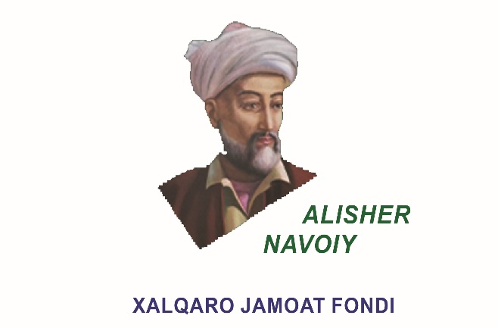

INFORMATION LETTER
The International Public Foundation "Alisher Navoi" announces the holding of the International Symposium on the theme "NAVOI AND EASTERN RENAISSANCE" on February 9, 2023, on the day of the 581st anniversary of the birth of the great poet and thinker, public figure Alisher Navoi.
It is planned to receive articles to the International Symposium in the following areas:
1. Eastern Renaissance: science, literature and culture.
2. Sufi poetry and creativity of Alisher Navoi.
3. The role of Alisher Navoi's literary heritage in the world civilization.
4. Book art in the time of Timurids.
5. Problems of creating a scientific biography of Alisher Navoi.
6. World navoiology: yesterday, today and tomorrow.
7. Problems of translation of works of Navoi into foreign languages.
8. Alisher Navoi and world linguistics.
9. Navoi "Khamsa" and issues of comparative studies.
10. Alisher Navoi and issues of literary influence.
Articles will be accepted in Uzbek, Russian, English, French, Persian and Turkish languages.
Please pay attention to the following:
Lectures and presentations must be sent to the e-mail address info@navoifound.uz until December 30, 2022. The organizing committee reserves the right to make technical changes to the materials, and also not to comment on this if the article is not accepted and returned.
Selected articles will be published proceeding of the International symposium materials and, the participants will be awarded with a certificates.
Requirements for the articles:
The font is Times New Roman, 14, and it is recommended that the spacing of the lines be one. All pages of the article text page leave a distance of 3 cm from left, 1,5 cm from right and 2 cm from up and bottom. The maximum size of the article is not limited, but it is recommended that the minimum amount should not be less than 12 pages.
Requirements for the structure of the article:
- The topic of the article should be as short and concise as possible, and should clearly indicate the direction of the article and, must written with capital letters;
- Information about the author must include the author's name (first name, middle name), place of work and position, academic degree and title, email address and contact telephone numbers;
- Abstract is a section that contains no more than 100 words, briefly covering the overall content of the article. The abstract of the article is a summary of the author's scientific and practical contribution based on the research problem, its relevance, the methodology used to reveal the research problem, the results of the research, the full content of the article. Abstract of articles must be in Uzbek, Russian and English;
- Keywords reveal the content and purpose of the article in the shortest possible context. The article will be easily found on scholar.google.com or google.com if each keyword is repeated 5 to 10 times in the main text. Keywords should be presented in Uzbek, Russian and English.;
- The content of the article should consist of introduction (Introduction), main part (Main part), results and discussion (Results and Discussions), conclusions (Conclusions), references (references).
- All references used in the article are recorded in alphabetical order.

Phones for inquiries: Office: +998 55 5031441
Mob: + 998 88 198-14-41, +998977505401
E-mail: info@navoifound.uz, asyalka@yandex.ru

