UDC 004.4

**ARTICLE TEMPLATE FOR PUBLICATION   
OF CONFERENCE MATERIALS (up to 10 words)**

1+***Surname N.P.,*** 2***Surname N.P.,*** 1,2***Surname N.P.***

+corresponding_author@email.uz

1Organization, city, country.

2Organization, city, country.

**Abstract:** The abstract should state the essential facts of the work, and should not exaggerate or contain material that is not in the main body of the publication. It is recommended to write an abstract in accordance with the structure of the article, including introduction, methods, results and conclusions. At the same time, direct copying of fragments of the text of the article is not desirable. The subject, theme and purpose of the work are indicated if they are not clear from the title of the article. The information contained in the title of the article should not be repeated in the text of the abstract. Avoid unnecessary introductory phrases (for example, (“the author of the article is considering ...”) and complex grammatical constructions. The text of the abstract should be concise and clear, free from secondary information, unnecessary introductory words, general and insignificant wording. The text of the abstract should be coherent, the disparate stated provisions should logically follow each other. Abbreviations and symbols are not allowed, except for commonly used ones. The abstract should not contain formulas, references to literature, drawings, etc. The volume of the abstract is determined by the content of the article, and should be from 100 to 200 words.

**Keywords:** from five to seven keywords or phrases separated by commas, which should not repeat words from the title.

# **Introduction**

The introduction is the opening part of the article, which deals with objectives of the study, describes the essence of the problem being solved, analyzes the reasons for choosing the topic. The introduction should not repeat the abstract, contain "water" and detached arguments that are not directly related to the study.

Mandatory for the introduction is a review of the literature, which should integrate this article into the body of existing scientific materials and publications. It is recommended to include 10 to 15 sources. It is necessary to observe the correctness of quoting, direct borrowing of annotations and entire fragments of text from sources is not allowed. The review of the literature should not be turned into a series of paragraphs beginning with the words “In the work [1]…” or a pile of bibliographic references without explaining the reasons for considering the works of the cited authors. It is also not allowed to use excessively multiple citations at a time, for example [3-12].

It is not recommended to use template expressions like: “This topic is widely represented in the works of domestic and foreign scientists”, “The topic of this study is poorly developed by domestic scientists”, etc.

A well-written introduction should answer the following questions: 1) Why is the research topic relevant? 2) What is known about the subject of research? 3) What is unknown? 4) How does this study differ from the work of other scientists and what niche does the performed work in the corpus of similar research papers occupy? 5) Is the research apparatus clear enough to readers?

# **Methods**

In this section of the article, the author of the scientific study describes the methodology and demonstrates the reasons for choosing it. In general, the content of this section is a retelling of the report on the course of the study of the object with a description of the specific problem being solved, the substances involved, equipment, mathematical apparatus, etc. Mathematical formulas and technologies on the basis of which the surveys were carried out are indicated here. It is recommended to observe the validity of the data and the completeness of the description of methods for solving problems so that after publication, other scientists can reproduce the presented study.

## **2.1 Mathematical model (Problem statement)**

To improve the readability of the article, a more detailed structuring of this section into subsections is welcome. For example, for research in the fields of computational and applied mathematics, data processing technologies and artificial intelligence, it is traditional to single out a subsection containing the formulation of a mathematical model or a specific problem statement describing the characteristics and purpose of the included equations, parameters, boundary conditions, etc., as applied to the object under study.

## **2.2 Initial data (Descriptions of datasets)**

It is recommended to provide a description of the source data, explaining the appropriateness of their use in the study and their validity. The description of the data is given, regardless of whether the model problem is solved or the data of a real object is used. For recognition and classification tasks, it is recommended to accurately specify the source of datasets and the method of obtaining them. When specifying the initial values ​​of units of physical quantities, for example, in tabular form, it is necessary to strictly adhere to the accepted notation of the International System of Units (ISI).

## **2.3 Computational algorithm (Solution method)**

In the subsection describing the method for solving the problem, computational algorithms, block diagrams of algorithms, description of the conditions for conducting experiments can be given. It is recommended to indicate whether there are limits, assumptions and limitations that take place in relation to the set task, the chosen methodology and its solution, and the conditions for conducting experiments. The completeness of the description of the method for solving the problem should be sufficient for the reader to get a clear understanding of it, directly from the article. It is not allowed to completely omit this part, giving references to previously published works.

## **2.4 Formulas**

Any formulas and individual mathematical notations (symbols, letters, expressions etc.), found in the text must be typed strictly using the "MathType" formula editor! It is not allowed to use the built-in MS Word tools for typing formulas, as well as the use of ordinary text characters. Moreover, even if they are enough to write a mathematical expression.

 (1)



Formulas located on separate lines, both numbered and not numbered, are aligned in width with the following tab settings: 8.5 cm - centered, 17 cm - right. Paragraph indent in lines with formulas is set to 0 cm.

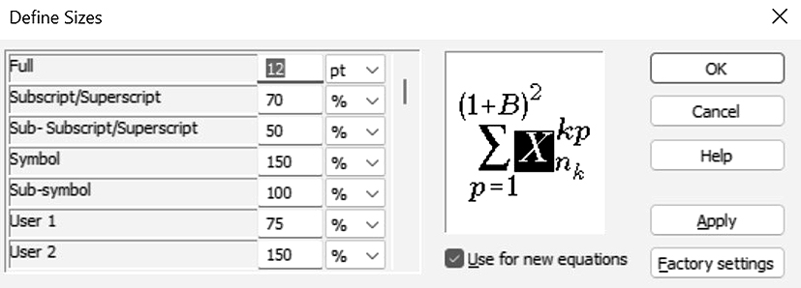

**Pic. 1** Formula size settings

The settings that determine the size of the elements of MathType formulas are shown in Fig. 1. All formulas in the text must have the same size! Therefore, when copying formulas from other files, you must make sure that this requirement is met. To do this, it is recommended to launch the Format Equations command from the MathType menu with the ones shown in Fig. 1 parameters.

# **Results**

The "Results" section contains details what was found and what was achieved in the course of a particular research study. Traditionally, this is the shortest, but extremely important, key section of a scientific article. The authors are required to present the results of the work done in the form of a layout of the data of the experiments performed in tables and/or graphs. Illustrations and links to the received data sets (datasets) are allowed.

## **3.1 Tables**

The number and content of tables should be determined by the logic of the article. An example of the design of tables is presented below (Tables 1 and 2).

**Tab. 1** Table header

|  |  |  |  |
| --- | --- | --- | --- |
| **№** | **Показатель** | **Value** | **Value** |
| 1 | Indicator 1 | 0.1 | 0.5 |
| 2 | Indicator 2 | 0.2 | 0.7 |
| 3 | Indicator 3 | 0.3 | 0.9 |
| 4 | Indicator 4 | 0.4 | 0.6 |
| 5 | Indicator 5 | 0.5 | 0.8 |

When including tables in the text of the article, the following must be taken into account: the names of the tables must strictly correspond to the data presented in them and be as short as possible; the minimum font size for tables is 10 pt; all tables should be mentioned in the text of the article, as a rule, before the table; the absence of any data in the table should be appropriately explained in the text; color design of tables is not allowed; autofit all tables is set to “Fit to page”.

**Tab. 2** Table header

|  |  |  |  |
| --- | --- | --- | --- |
| **№** | **Indicator** | **Value** | |
| **D. 1** | **D. 2** |
| 1 | Indicator 1 | 0.1 | 0.5 |
| 2 | Indicator 2 | 0.2 | 0.7 |
| 3 | Indicator 3 | 0.3 | 0.9 |
| 4 | Indicator 4 | 0.5 | 0.8 |

It is not recommended to include tables with a large number of columns in the text of the article. In exceptional cases, it is allowed to insert wide tables that are rotated 90 degrees counterclockwise and occupy the entire page. In this case, the table, including its number and title, is inserted as a bitmap. At the same time, the requirements for the design and size of fonts are preserved.

It is allowed to divide the table into two or three parts. In this case, the names for each of the parts of the table are indicated in the form “Tab. 1 ... continued”.

## **3.2 Figures**

The number and content of the figures is determined by the logic of the article. When including figures in the text of the article, the following should be taken into account:

* titles of figures should strictly correspond to their content and be as short as possible;
* the minimum size of any inscriptions in the figures is 10 pt;
* figures should be mentioned at least once in the text of the article;
* the content of the figures must be prepared in such a way as to be fully understandable in monochrome printing.

A sample figures (graphic) is presented below (Fig. 2).

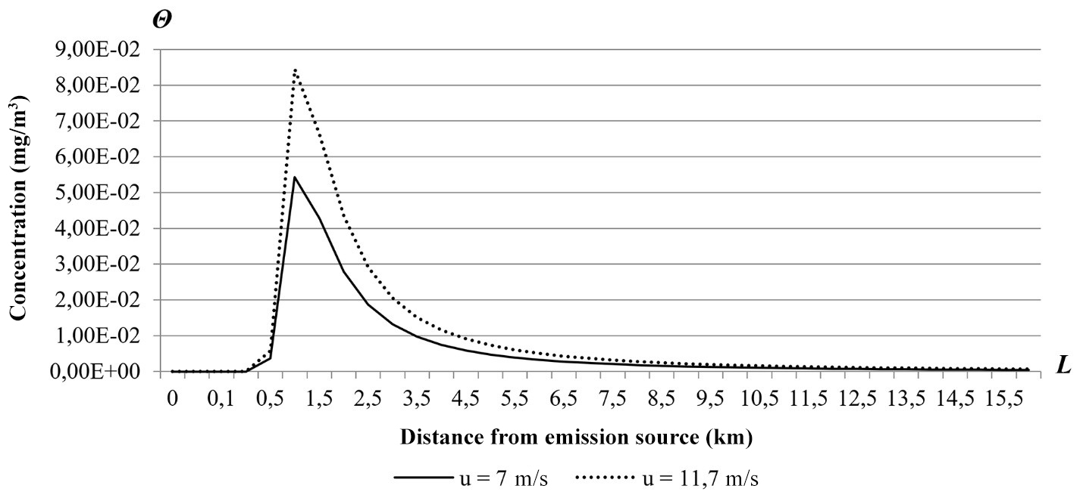

**Fig. 2** Figure title  
Additional caption text.

It is recommended to prepare figures initially in black and white. The use of color images is allowed only if their monochrome printing does not affect the information content.

Please note that any illustrations in the article - drawings, diagrams, schemes, etc., must be included in the article in raster form! The resolution of the drawings is at least 300 dpi. The use of the built-in drawing tools of MS Word (canvases, shapes, lines, inscriptions, etc.) is strictly prohibited.

All the necessary designations of the axes and units of measurement must be provided on the graphs. An exception is allowed only when the content of the graph is clearly understood from the context.

# **Discussion**

In this part of the scientific article, the author presents his interpretation of the data obtained as a result of the study. It is necessary to explain the similarities and differences in the author's approaches and in general the vision of the work. It is recommended to compare the obtained results with the experience of other scientists, known facts and explanations of phenomena. To note whether the stated hypothesis was confirmed by the results of the study, or, on the contrary, to give doubts about some of the conclusions.

If it is obviously clear that the "Discussion" section will be small in volume, then, at the request of the authors, it is allowed not to single it out separately. In such a case, part of the discussion of the results can be included directly in the "Results" section.

One way or another, the part of the article with the description of the results and their discussion should answer the following questions: 1) Are the results well-presented and understandable to readers? 2) Do the results of the study correlate with the experience of other scientists? 3) Are there weaknesses in the study? 4) Are the results applicable for further research? 5) Was the hypothesis confirmed by the results of the study?

# **Conclusion**

This section provides clearly articulated information that summarizes the study.

From this part of the article, it should be clear whether the author succeeded in achieving the goal, proving or refuting some hypothesis. It is recommended to note the following points:

- the significance of the work done for the development of science (scientific significance);

- what do the obtained results bring to the community of scientists;

- prospects for applying the results of the work in practice (practical significance);

- what aspects of the study require further study.

Direct repetition of text fragments from the previous sections of the article, in particular, from the discussion section of the results, is not allowed.

The formatting of all elements of the article and text, performed in this template, is a standard. We especially draw the attention of the authors to the need to comply with it. To avoid changes, when copying large fragments of text from other files, paste must be done in the “Keep Text Only” mode. It is also possible set the appropriate settings in the “Options” dialog box of MS Word in the “Advanced” tab.

It is necessary to adhere to the fact that the full text of the article (from 5 to 10 pages), designed according to the template, completely occupies all pages. Meaning prevent the last page from filling by less than half.

As practice shows, the correct compilation of lists of references causes difficulties for scientists. Bibliographic references in the list of references are proposed to be made according to one of the widespread styles: GOST R 7.0.5-2008, APA, MLA, Oxford, Harvard, Chicago. Within one article, it is necessary to adhere to only one chosen style and strictly comply with its requirements.

Below are examples of bibliographic references for different types of documents.

# **References**

1. *Berljand M.E.* Prognoz i regulirovanie zagrjaznenija atmosfery. – L.: Gidrometeoizdat, 1985. – 272 s. (in Russian)
2. *Hanna S.R., Briggs G.A., Hosker R.P.* Handbook on atmospheric diffusion. – Springfield: US Dept. of Energy, 1982. – 102 p.
3. Meteorologija i atomnaja jenergija : per. s angl. / pod red. *N.L. Byzovoj, K.P. Mahonko*. – L.: Gidrometeoizdat, 1971. – 647 s. (in Russian)
4. Air quality guidelines. Global update 2005. Particulate matter, ozone, nitrogen dioxide and sulfur dioxide / World Health Organization. – Copenhagen: Druckpartner Moser, 2006. – 484 p.
5. *Androsov A.A.* Modelirovanie prilivnoj dinamiki v soglasovannyh krivolinejnyh koordinatah : avtoref. dis. kan. nauk. – SPb.: 1998. – 20 s. (in Russian)
6. *Harchenko E.V.* Ispol'zovanie matematicheskih modelej perenosa i rassejanija radionuklidov v atmosfere dlja upravlenija riskami na stadii proektirovanija atomnyh jelektrostancij : dis. ... kand. nauk : 25.00.30 : zashhishhena 24.03.2016. – Sankt-Peterburg, 2016. – 117 s. (in Russian)
7. *Kakareka S.V., Salivonchik S.V.* Primenenie modeli AERMOD dlja rascheta rassejanija vybrosov zagrjaznjajushhih veshhestv ot stacionarnyh istochnikov // Geografija i prirodnye resursy. – 2015. – № 1. – S. 175-184. (in Russian)
8. *Verzicco R., Orlandi P.* A Finite-Difference Scheme for Three-Dimensional Incompressible Flows in Cylindrical Coordinates // Journal of Computational Physics. – 1996. – Vol. 123, Issue 2. – P. 402-414.
9. *Constantin A., Johnson R.S.* Ekman-type solutions for shallow-water flows on a rotating sphere: A new perspective on a classical problem // Physics of Fluids. – 2019. – Vol. 31. – P. 1-15. – DOI: 10.1063/1.5083088.
10. *Ravshanov N., Sharipov D., Ahmedov D.* Ispol'zovanie onlajn servisov dlja komp'juternogo modelirovanija i prognoza jekologicheskogo sostojanija regionov // Sovremennye materialy, tehnika i tehnologii v mashinostroenii: sb. nauch. statej III mezhdunar. nauch.-prakt. konf. – Andizhan: AMI, 2016. – S. 434-438. (in Russian)
11. *Holoubek I., Hrebicek J., Dusek L.* ICT Tools For Environmental And Human Risk Assessment // Proc. of the 4th Int. Congress on Environmental Modelling and Software. – Barcelona, Catalonia: iEMSs, 2008. – P. 2109-2117.
12. *Anfossi D., Physick W.* Lagrangian particle models // Air Quality Modeling Theories, Methodologies, Computational Techniques, and Available Databases and Software. Vol. 2 - Advanced Topics / ed. *P. Zannetti*. – Pittsburgh, PA: Air & Waste Management Association, 2005. – P. 93-161.
13. Inventarizacija istochnikov i vybrosov zagrjaznjajushhih veshhestv v atmosfernyj vozduh / Sajt gruppy kompanij «Jekologicheskij centr». – URL: https://docs.cntd.ru/document/456074826 (retrieved: 07.08.2020). (in Russian)
14. *Johnson M.* How ICTs can help tackle climate change // Newsletter eLAC. – 2011. – No. 14. – P. 2. – URL: https://bit.ly/3fQWiDM (retrieved: 06.08.2020).
15. SRTM 90m Digital Elevation Database v4.1 / CGIAR-CSI Consortium for Spatial Information. – URL: https://bit.ly/2J8Lnuv (retrieved: 07.08.2020).